First Report with Excel

# Executive summary

We exported the sales data from our data base and we conducted some analysis to gain insights into some of our sales operations and study ways to enhancing our services based on a certain scope.

## Scope:

* customer loyalty
* strength and weakness points
* Performance
* Customer Experience

## Data Specs

Here are the tables we used to conduct our analysis

* Orders Table
* Return Table
* Shipping Cost Table
* People Table

# The Analysis

## Customer loyalty

**What is the most used ship mode by our customers?**  
 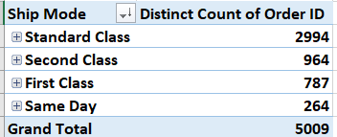

Based on the table above we counted the number of times each shipping mode occurred in the orders table  
And we found that the standard class shipping mode was the most one used by our customers.

Recommendation:

*We should focus more promotions on the standard shipping mode as it the most used.

*We should find ways to reduce the cost of the standard shipping mode and make sure it’s profitable as it is the most used shipping mode.

*Same Day shipping mode was the least used shipping mode which might be better to revise the cost and possible scenarios where it might be removed.

**Who are our top 10 CST in terms of sales, and order frequency?**

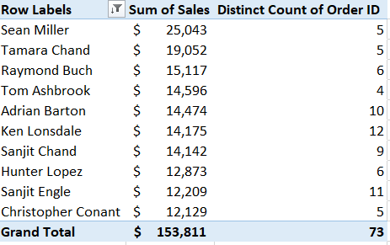

Based on the table above there are the top 10 Cst in terms of sales and the count of orders they have made.

We recommend to ……………..

**Also our top 10 Cst in terms of orders?**

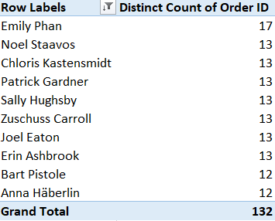

And there are the top 10 customers make orders

## Strength and weakness points

**Which segment of clients generate the most sales?**